**Experiment 1: LED Flasher**

**Aim:** Design an LED Flasher.

**Apparatus:** LEDs, Resistance (270 ohm), Breadboard, Arduino, wires.

**Circuit Diagram:**

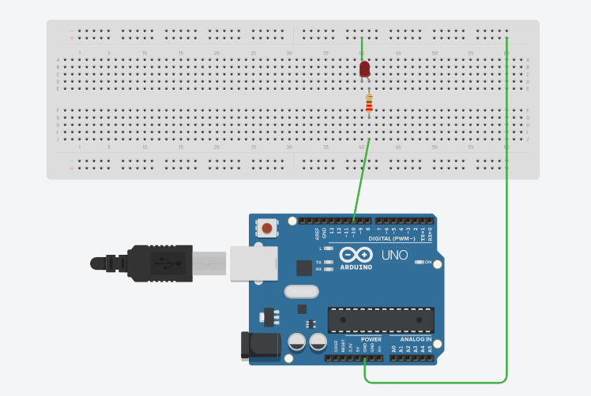

**Theory:**

1. Concept Used:
2. In Arduino, digital pins provide input as well as output but analog pins only provide input.
3. Resistance is used in series with LEDs to oppose current so that excess current may not damage LED.
4. Current flows from anode to cathode and not in reverse direction through LEDs.
5. Learning & Observations:
6. Learn Basics of LED and identify cathode and anode of LED.
7. Circuit works only when p terminal of LED is connected to digital output pins and n terminal to GND.
8. In Arduino, digital pins are used to provide output to circuit.
9. LED may be damaged if we do not use resistance.

**Problems and Troubleshooting:**

1. Defining cathode and anode in any LED. It is solved by analyzing LED carefully.

**Precautions:**

1. Connections should be made carefully and clearly.
2. We should use resistance so that excess current may not damage any LED.
3. Program Code should be written properly.
4. LED should be checked before using in circuit whether it is working or not.
5. Give some delay time between ‘on’ and ‘off’ states of LED to distinguish.

**Learning Outcomes:**

1. Using the Breadboard and how connections are made inside a breadboard.
2. Learn about different parts of Arduino and how to use them.
3. Join different components of circuit like LED, Resistance in proper way.
4. We should use resistance of a certain value only.
5. Using ‘void setup’ and ‘void loop’.
6. ‘Void setup’ works for once but ‘void loop’ works for infinite time.

**Result:** LEDs blinking is observed after running Arduino.